Remote with PowerShell
- Legacy remoting
  - RPC
    - Leverages the endpoint mapper
  - Windows Management Implementation (WMI)
    - Leverages Remote Procedure Calls
    - Parameters
      - Namespace
      - Class
      - List
      - ComputerName
      - Credentials
    - Get-WmiObject –Namespace –root\cimv2 –list | Sort-Object (displays all available classes)
    - Get-WmiObject win32_Service –Computername deepthought.cyberdyne.com –credential tlr\m0155443 | format-table -AutoSize

  - Windows Remote management
    - Leverages the web services
    - SOAP based protocol
- WinRM
  - Must be enabled
    - Enable-PSRemoting
    - (set-WSManQuickConfig)
    - (Enables firewall exceptions)
  - Get-help About_remote-FAQ
  - Get-help About_Remote_Troubleshooting
  - Requirements
    - PowerShell v2
    - WinRM 2.0
    - .NET 2.0
  - Remote Architecture
    - Remote Shells are object oriented
    - Objects are created on the remote machine, then serialized and sent back using SOAP (Simple Object Access Protocol)
    - TCP port 5985
    - Communication is made using the WS-MAN protocol
- Interactive Session
  - Enter-PSSession
  - Enter-PSSession –computername EG-ISSINF-B01-Credentials
  - Only have 1 session at a time.
  - End the session!!!!!!!!
    - Exit-PSSession or Exit
  - Logs into the remote server using the credentials from your host credentials
- Persistent Session
  - Session that can be established from the back end of the server that needs to be closed manually
  - Leverage the New-PSSession, Get-PSSession, and Invoke-PSSession commands
    - $Session = New-PSSession –computername EG-ISSINF-B01
    - Invoke-command –Session $Session –Scriptblock {Get-Culture} | Format-Table –Autosize
    - THIS SESSION WILL STAY OPEN!!!!!!!!!!
  - 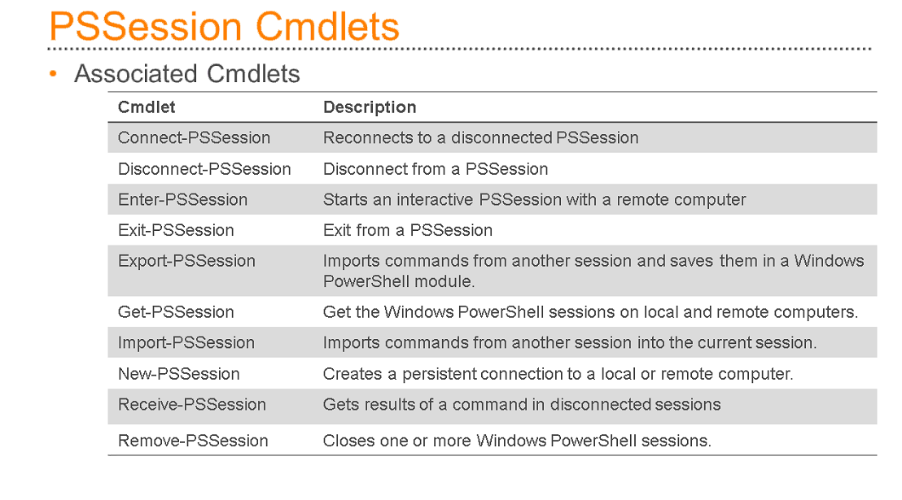
- Remoting into multiple computers
  - Invoke-Command
  - One or many machines
  - Run a command –scriptblock
  - Run a local script remotely –FilePath (This is on the remote machine)
  - –getcontent can be used to
  - Not user friendly with UNC paths \\servername\something.exe
- Starting Jobs
  - Start-Jobs
  - Starts a Powershell background job on the local or remote computer
    - Start-Job –ScriptBlock {Get-ChildItem –Path c:\Windows –Recurse}
    - Start-Job –FilePath c:\Scripts\Sample.ps1
    - Invoke-Command –ComputerName S1 –ScriptBlock {Get-EventLog System} –AsJob
  - Get-Job
    - Cmdlet to get all jobs in the current session that are running in the background
    - Get-job
  - Receive-Job
    - Shows the output on the listed job
  - Wait-Job
    - Cmdlet waits for the PowerShell background jobs to complete before displaying a command prompt
  - Stop-Job
    - Cmdlet will stop a PowerShell background job that is in progress
  - Remove-job
    - Cmdlet will delete a job
    - Job Must be Stopped
- Debugging
  - Write-Debug
    - Writes text to the powershell console to help understand how a program is running
    - Controlled by the $DebugPrefrence variable
  - $DebugPrefrence
    - Global variable that defines the behavior of the Write-Debug cmdlet
    - $DebugPrefrence = “Continue”
      - Displays Write-Debug Output to the console window
    - $DebugPrefrence = “Stop”
      - Displays Write-Debug and silence command.
- Errors
  - Two types of errors
    - Terminating
    - Non-terminating
  - Written to global variable called $Error
    - Array of 256 Entries
    - Each error is an object with a set properties that can be queried.
  - $ErrorActionPrefrence
  - 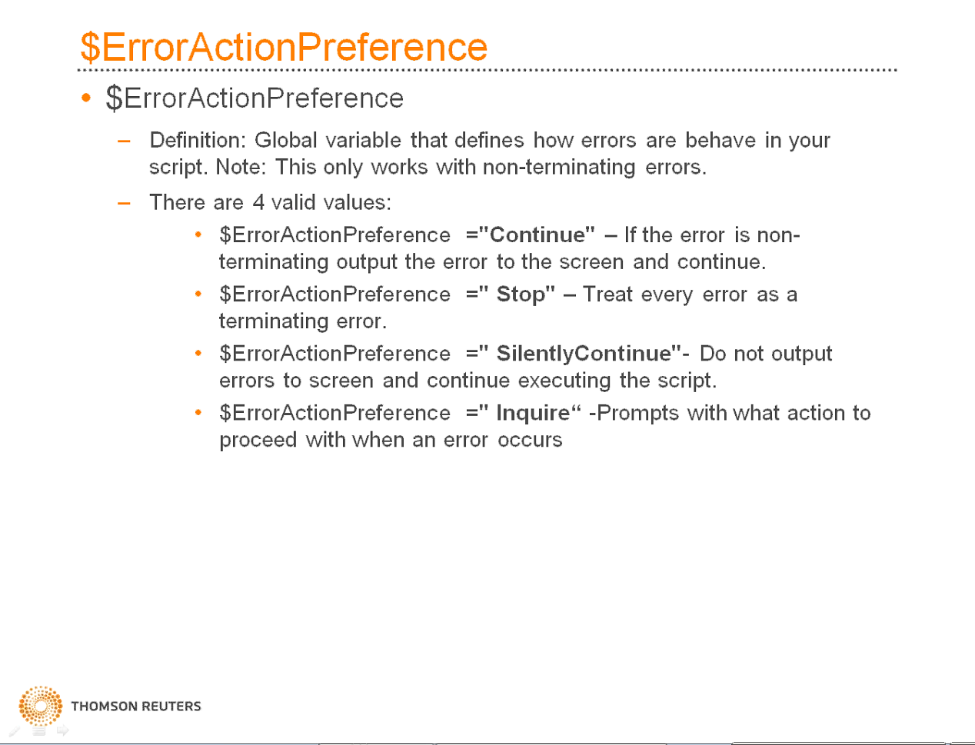
  - 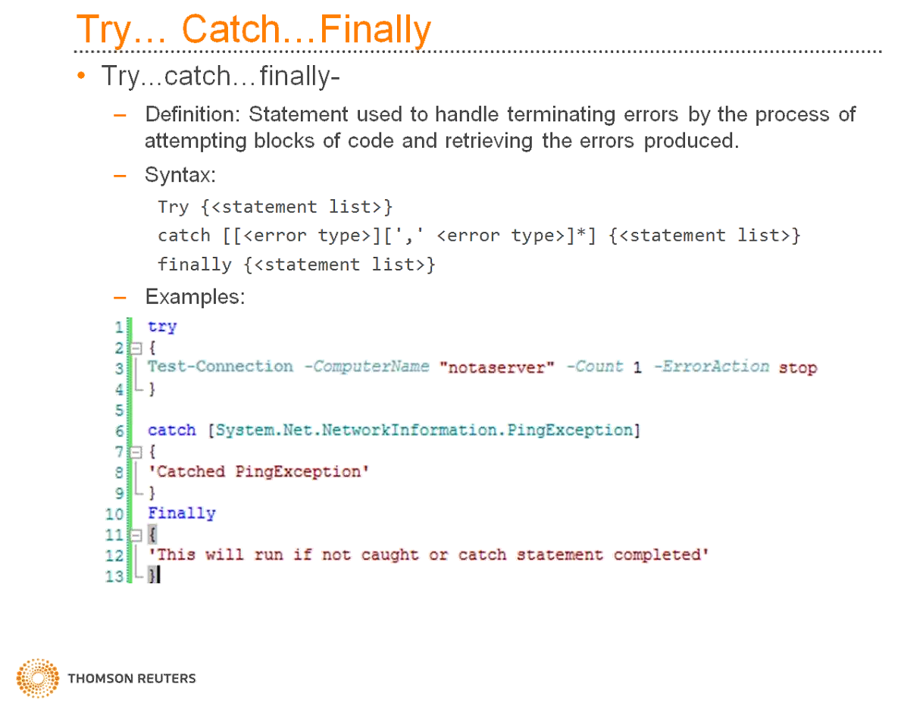
  - System.exception will catch everything.

